One Week in May 1944
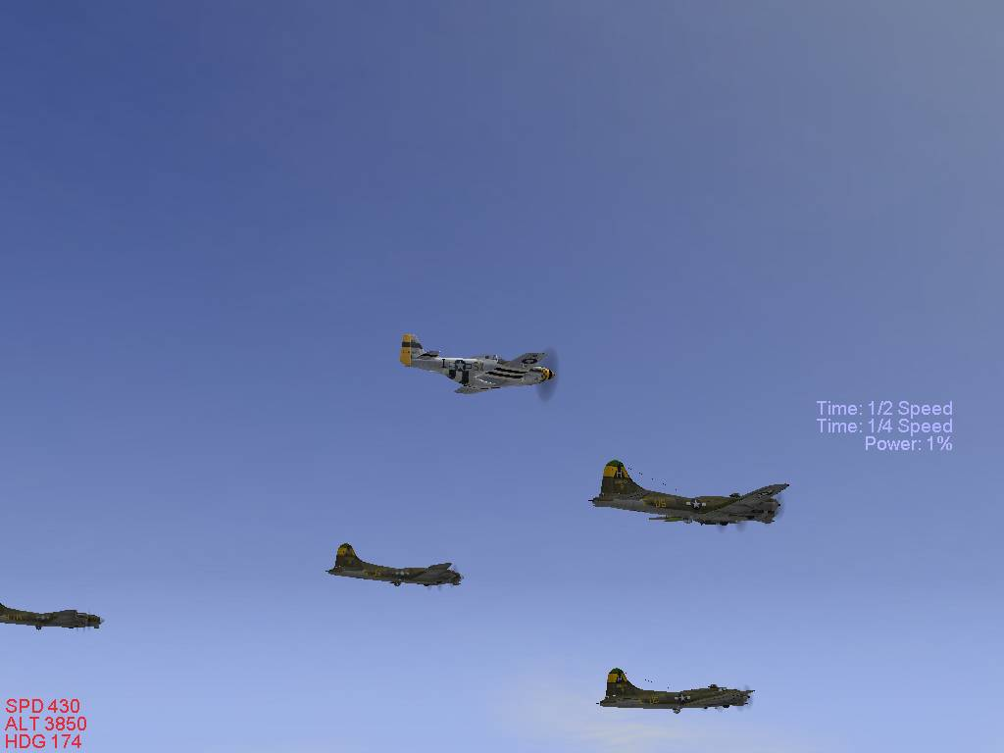
A mini-campaign by Poymando

This is a short seven mission campaign that is based on historical air operations that took place before the D Day invasion of June 6th 1944.
The player must start with the highest rank in the US campaign.
Feel free to drop a line if you have any questions or comments.
Enjoy!- Poymando
poymando@hotmail.com

